**Practical No 6**

**Aim :** Working with measures in the cube.

**Solution :**

1. Double click on ‘SalesCube’. Go to cube structure.

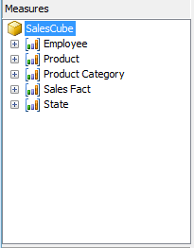

2. Right click on SalesCube -> New Measure.

Select Usage = “Sum” , Source table = “SalesFact” and Source

Column = “Sales_Dollars”.

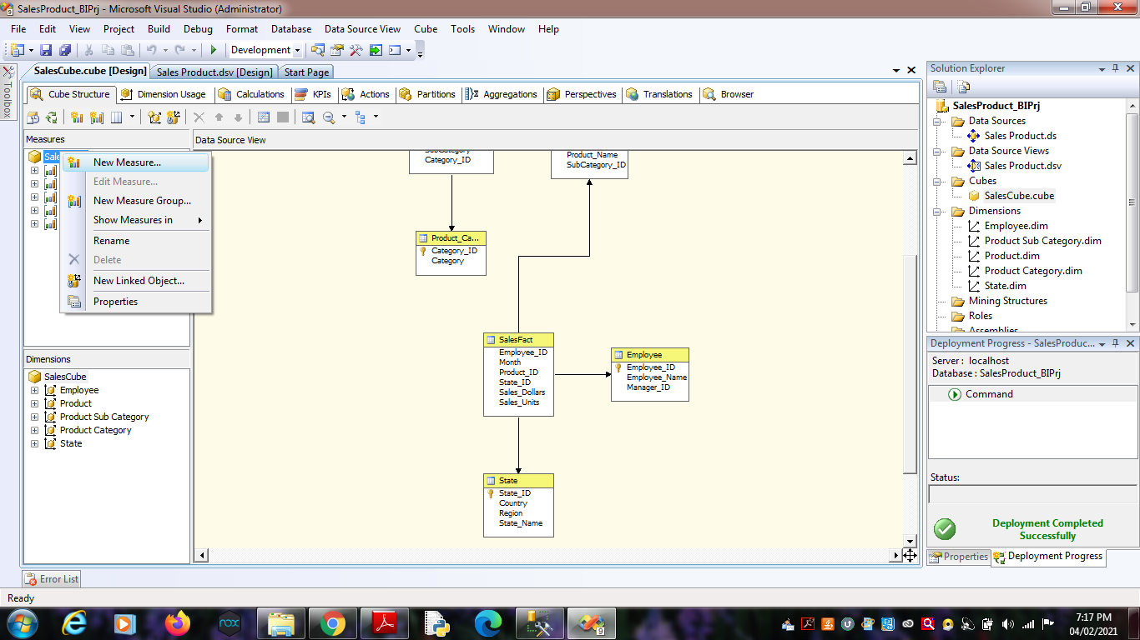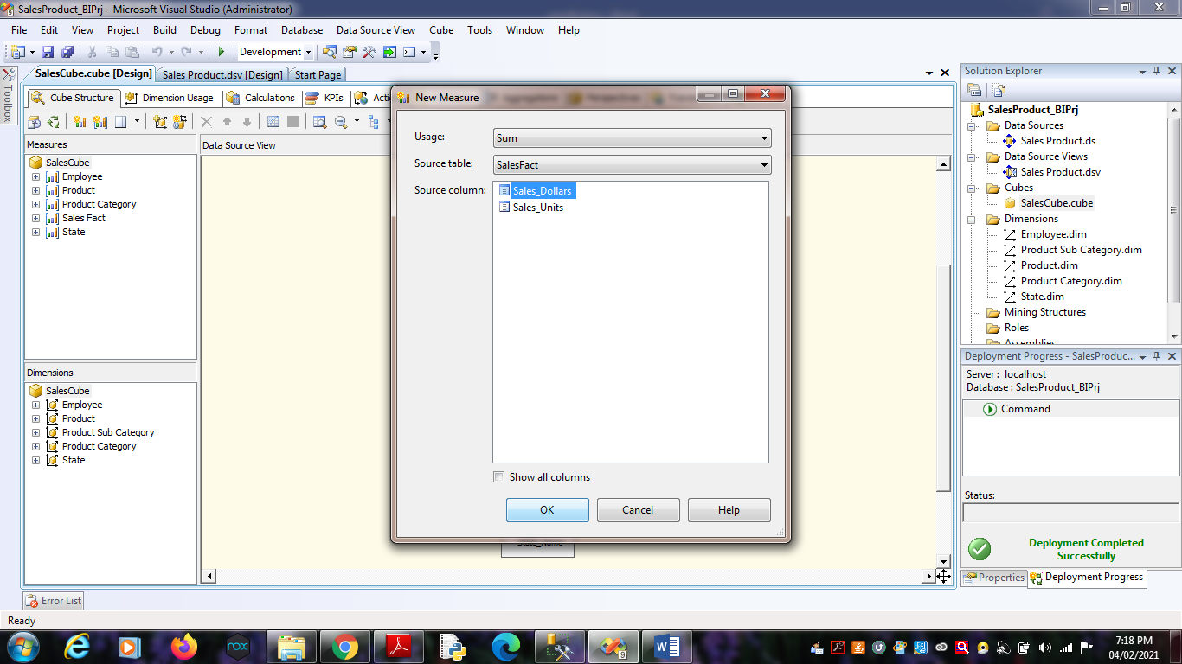Click on OK.

4. Process Cube and Go to Browser and Reconnect it. Right Click on

“Sum Sales Dollars” -> Add to Data Area.